**Task for Terraform-02. Date :02-09-2024**

**2) Execute all the templates shown in video.**

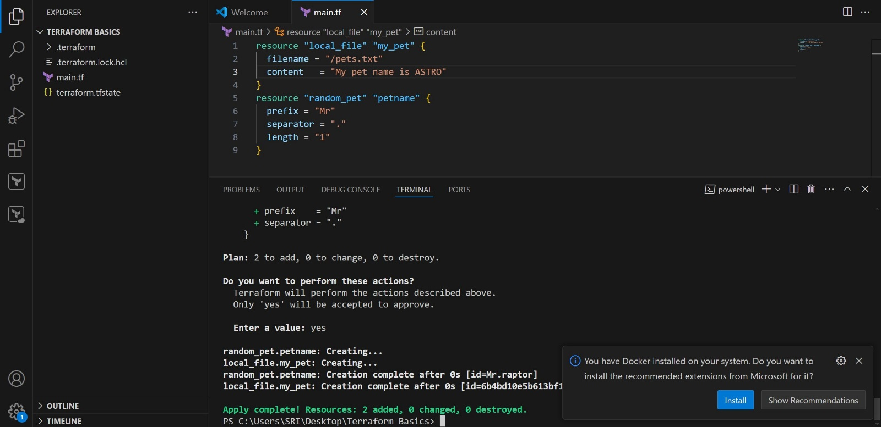

* Using create_befor_destroy _life_cycle

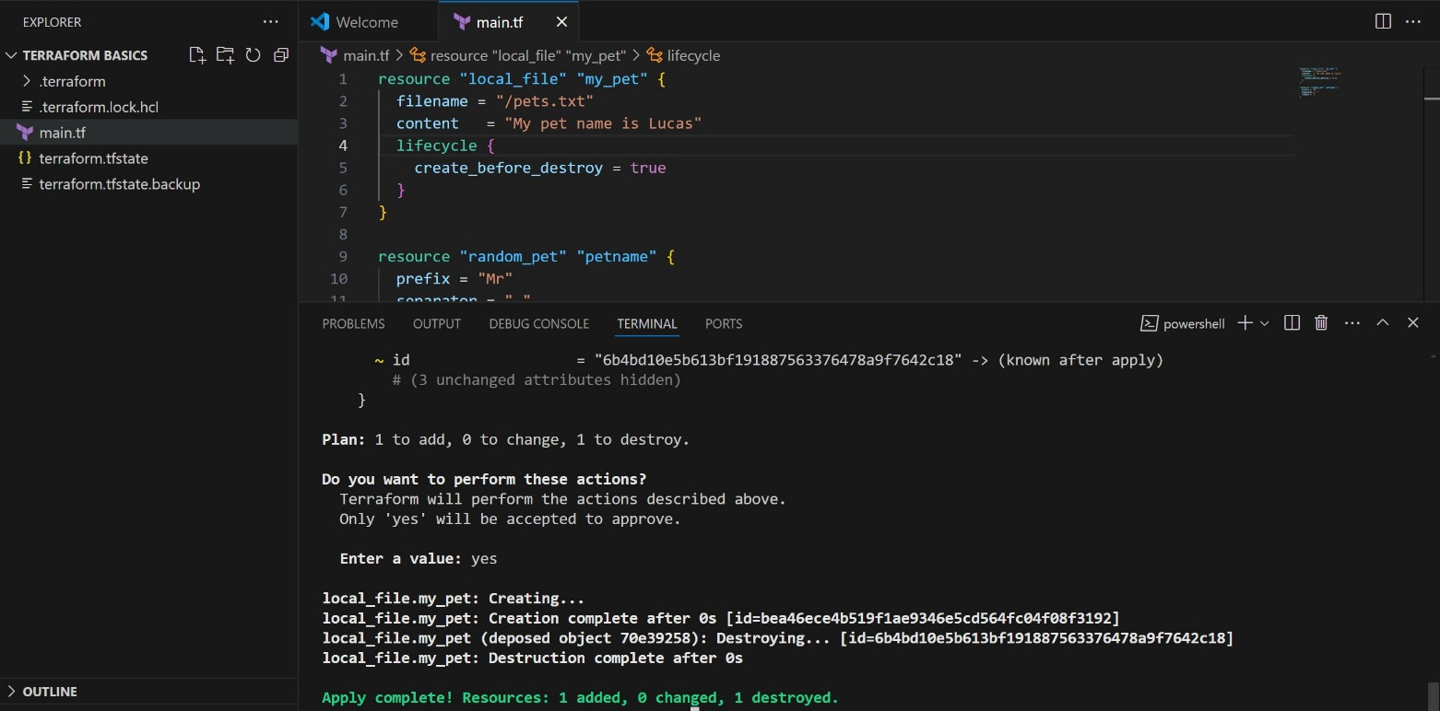

* Using prevent_destroy life cycle

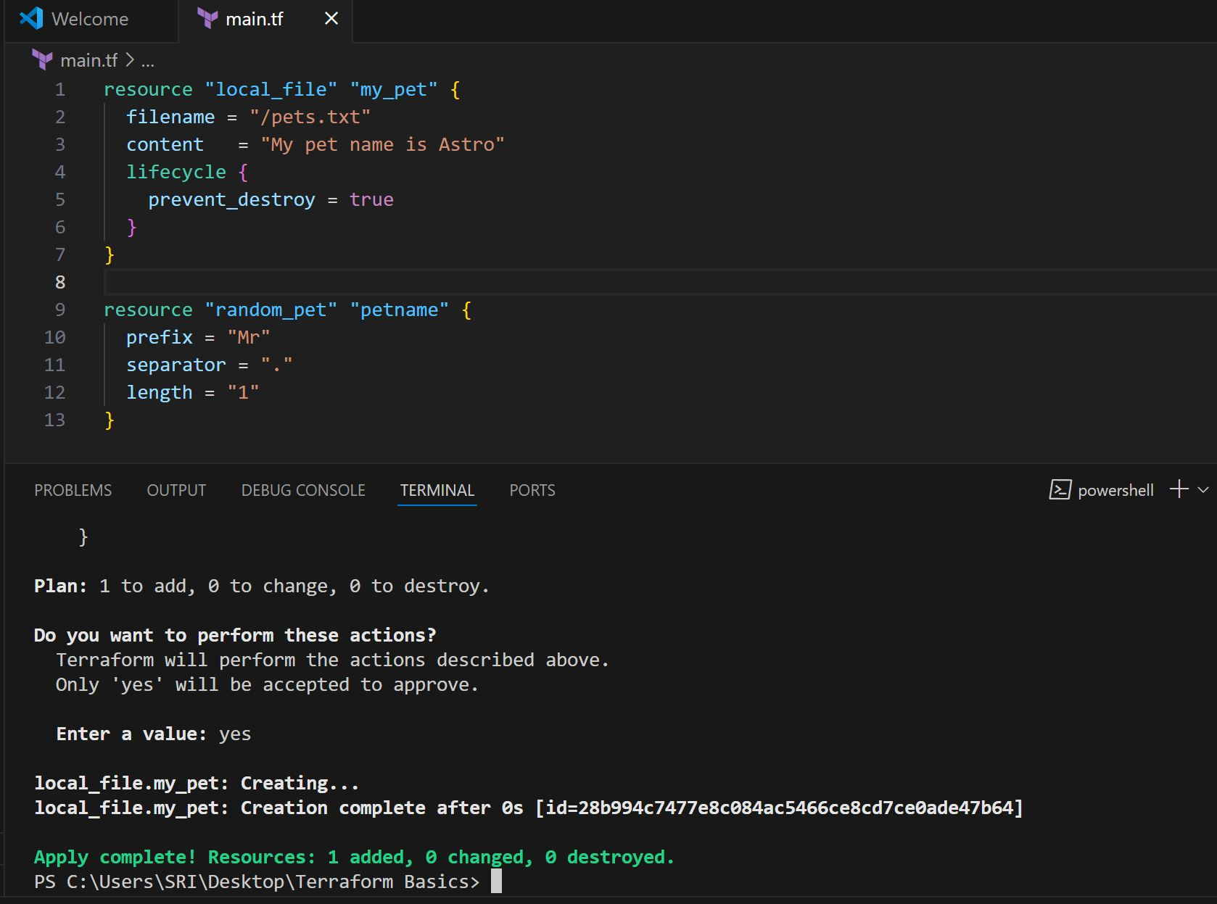

* Using ignore_changes life cycle

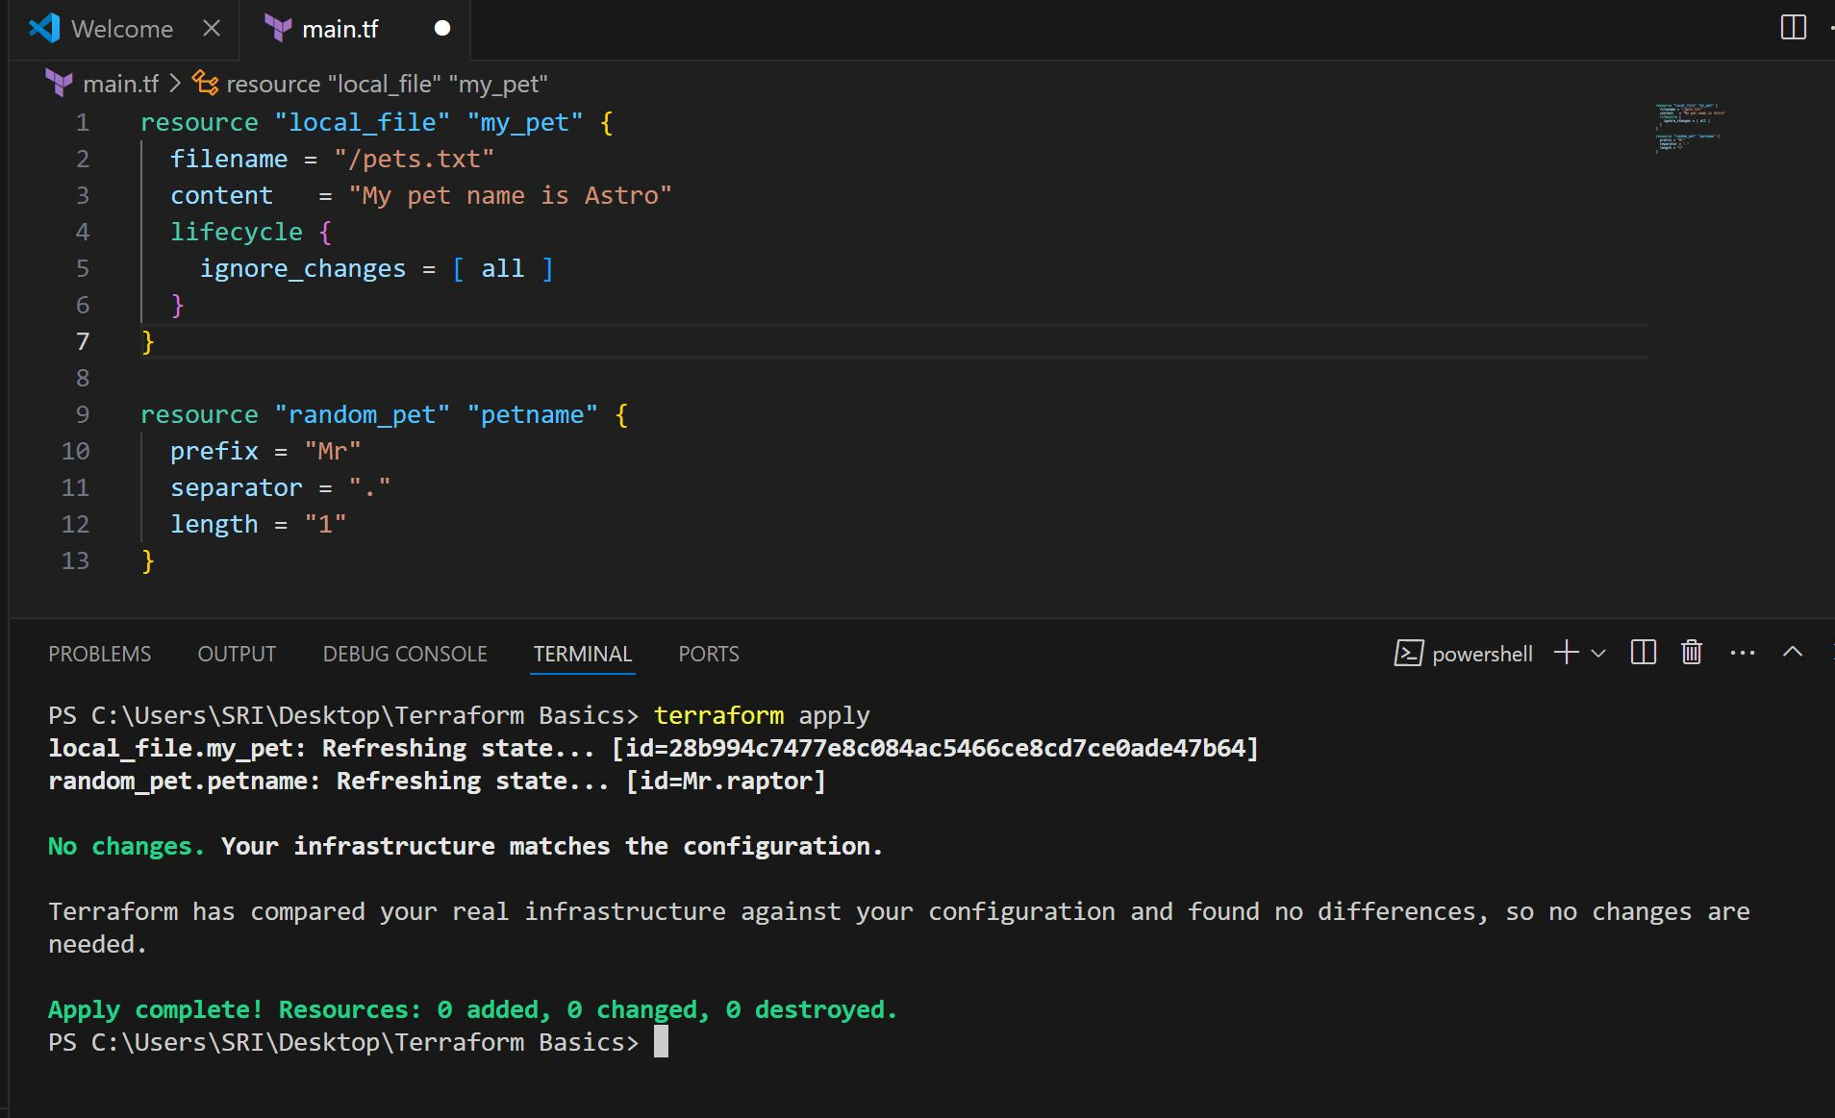

* Using variables.tf file and defining variables

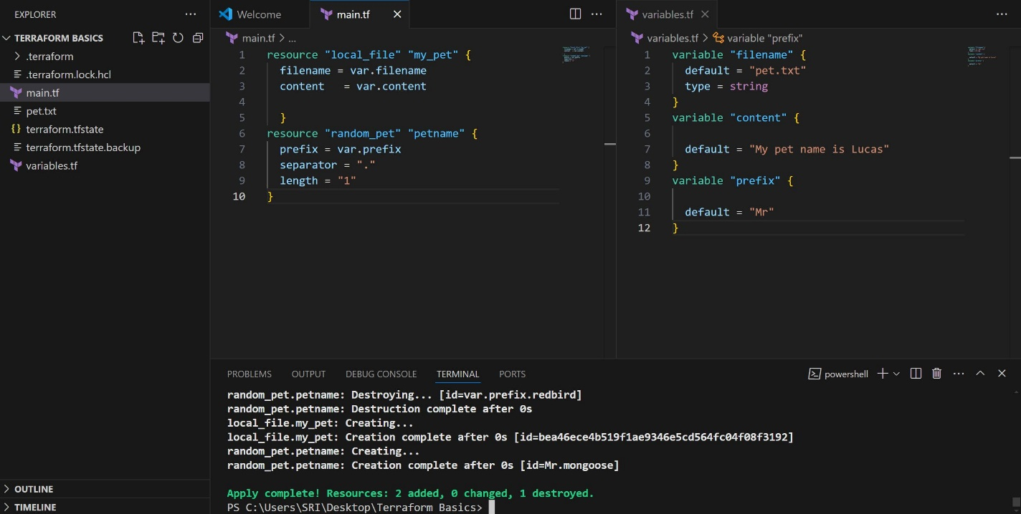

* Using command line arguments in variables

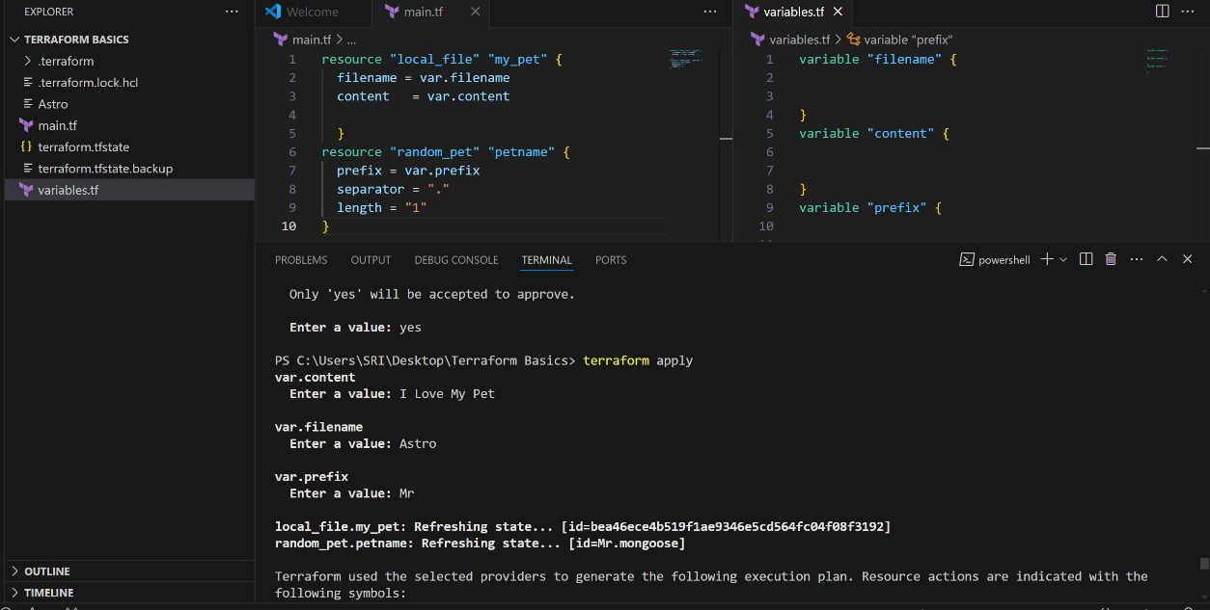

* Using command line arguments

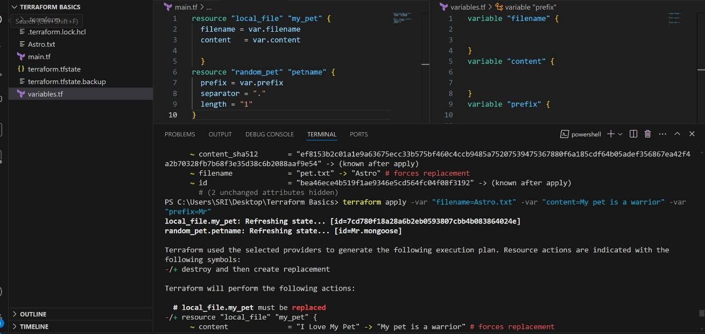

**3) Integrate terraform in jenkins using Terraform plugin.**

Download terraform in ec2 instance using

wget -O- https://apt.releases.hashicorp.com/gpg | sudo gpg --dearmor -o /usr/share/keyrings/hashicorp-archive-keyring.gpg

echo "deb [signed-by=/usr/share/keyrings/hashicorp-archive-keyring.gpg] https://apt.releases.hashicorp.com $(lsb_release -cs) main" | sudo tee /etc/apt/sources.list.d/hashicorp.list

sudo apt update && sudo apt install terraform

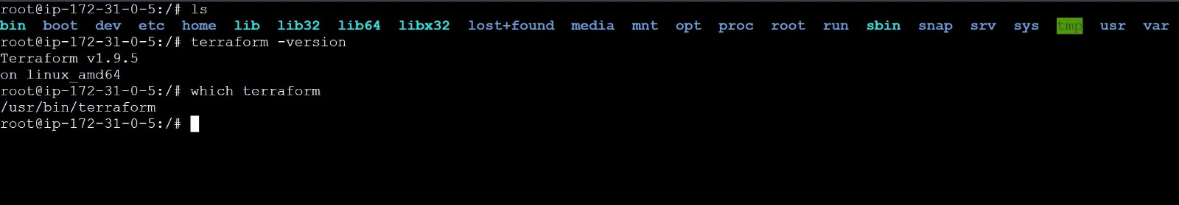

Download terraform plugin and update the location

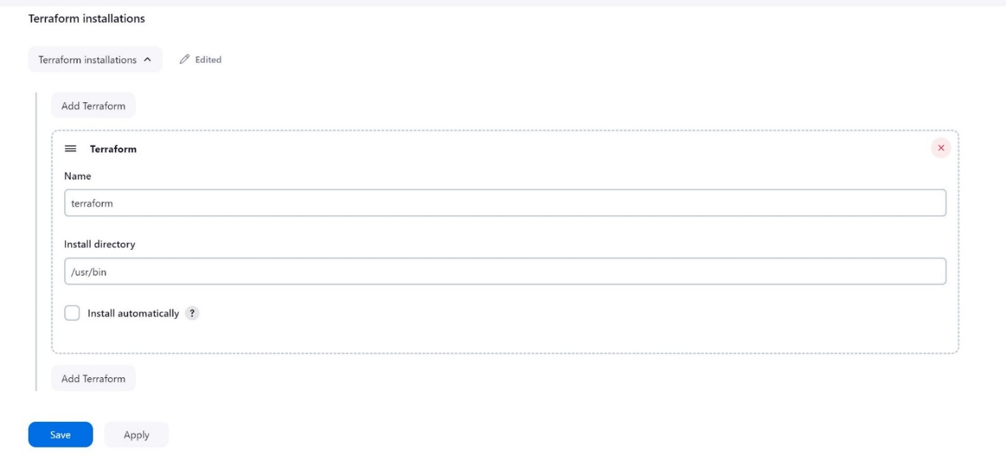

* Enter terraform commands
* terraform init
* terraform plan
* terraform apply -auto-approve

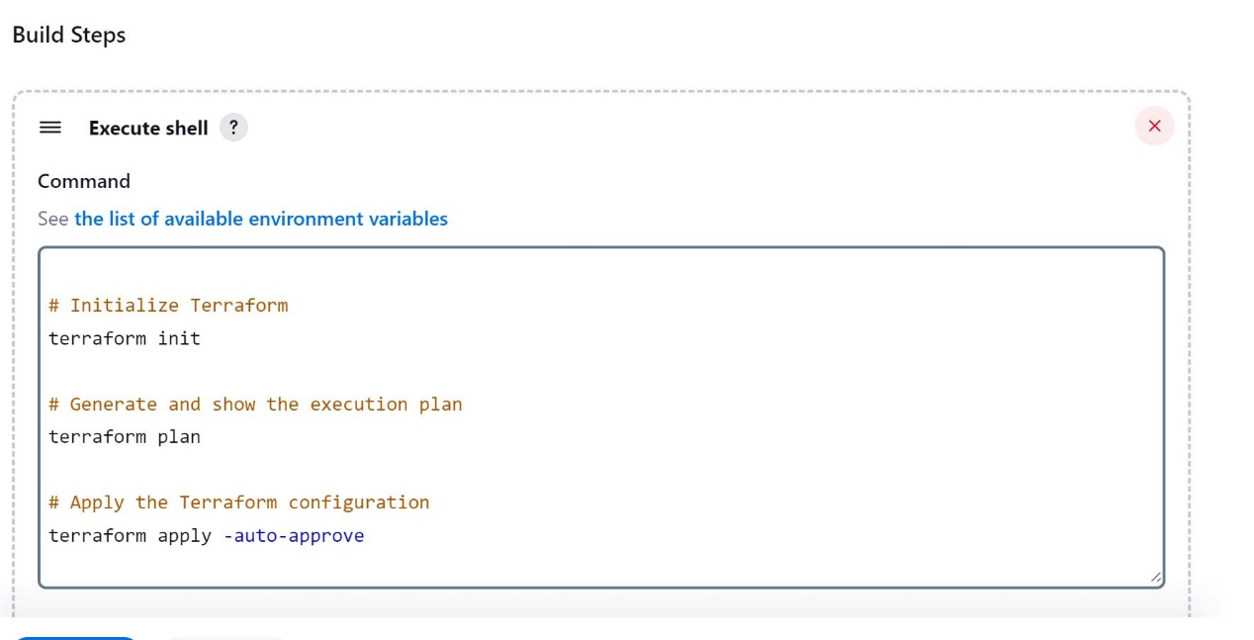

* once done save the job
* and build it

